Subject line: Deluxe Minis of Your Favourite Obagi Products

Deluxe Mini Obagi Medical Products!

The newest editions to the Obagi Medical Portfolio are available in Deluxe Minis

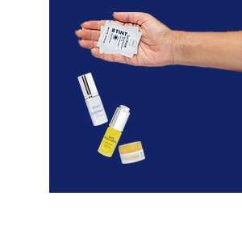
- Professional-C Microdermabrasion Polish + Mask 5g

- Obagi Daily Hydro-Drops 5ml

- ELASTIderm Facial Serum 5ml

PLUS

- NEW Obagi Sun Shield TINT Sachet2g

Available in a Warm or Cool tone, these sunscreens match the undertones of your skin, providing light coverage and triple protection, defending against both UVA and UVB rays PLUS infrared!

Pop into clinic

Pick up a sample of one of our favourite sun protectors:
Obagi Sun Shield TINT Broad Spectrum SPF50
And find out how you can claim a FREE Deluxe Mini

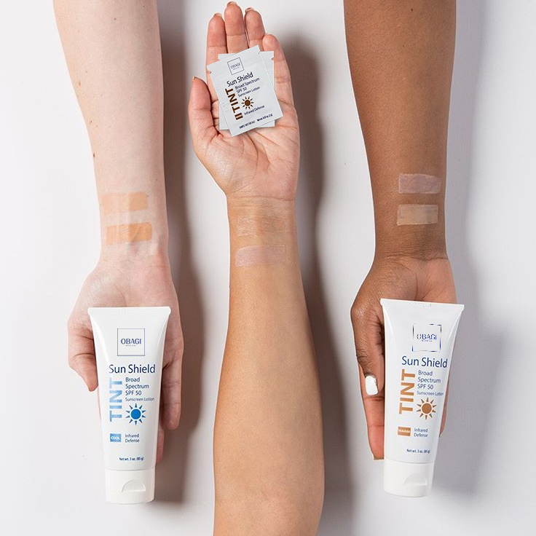

Find your shade at obagiuk.com @obagiuk

