Subject line: Summer Skincare Rewards

NEW: Summer Skincare Routines + Luxury Free Gifts!

Get the full package.

Collect your FREE:
Obagi Water Bottle
Deluxe Mini ELASTIderm Facial Serum 5ml
Summer Protocol Card
When you buy the Ultimate Obagi Summer Package.

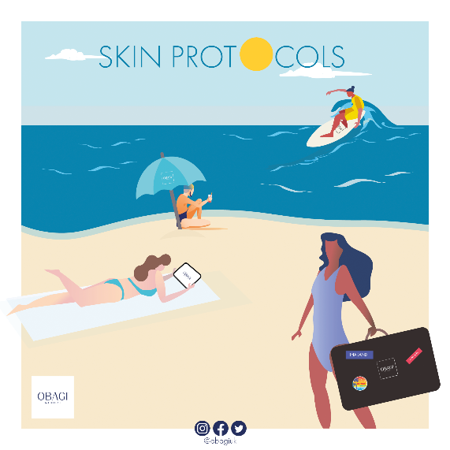

Are you a Sun Worshipper, Shade Seeker, or Outdoorsy Type? Or are you dreaming of a holiday in the sun?
(us too!)

Obagi’s got you covered with adjustments to your Nu-Derm Fx skincare routine that maintain your results and keep you safe in this summer.

View online and download your Obagi Summer Protocol, or contact us at [insert clinic name here] for product specific advice

The Ultimate Obagi Summer Package

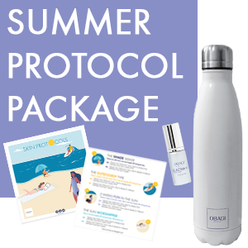
Purchase the Ultimate Summer Protocol Package to receive your:
FREE Obagi Water Bottle (for hot and cold beverages), Deluxe Mini ELASTIderm Facial Serum 5ml, and Summer Protocol Card

Ultimate Summer Protocol Package:
- Obagi Nu-Derm Fx System
- Professional-C Serum 15%
- ELASTIderm Facial Serum

What’s Included?

Obagi Skin Transformation!
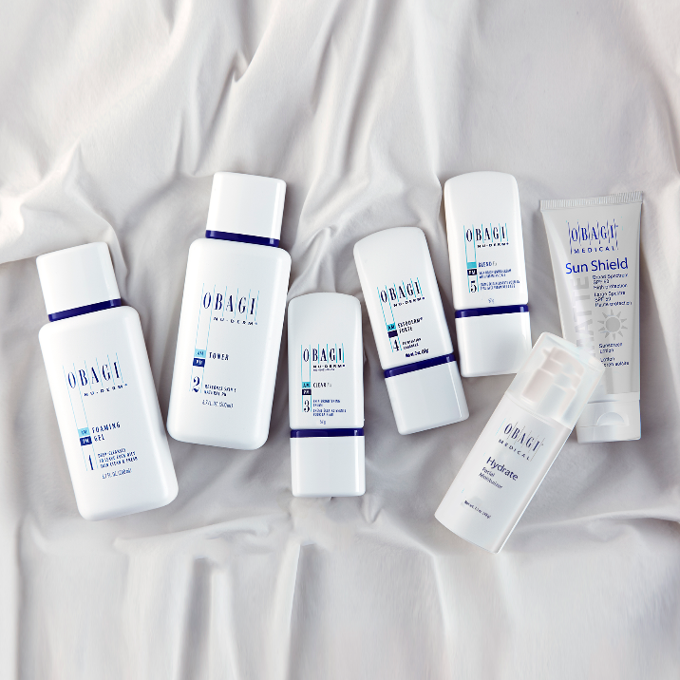
Obagi Nu-Derm Fx System improves the appearance of:
- Age spots
- Dull-looking Skin
- Erythema (redness)
- Fine Lines and Wrinkles
- Hyperpigmentation (discoloration)
- Rough skin
- Sallowness (yellowish complexion)
- Skin Texture
- Uneven Skin Tone

Did you know?
96% of patients were satisfied or very satisfied with the overall effectiveness of their treatment, and 91% of patients experienced improvement in the appearance of mottled hyperpigmentation at week 12!*

VITAMIN ‘SEA’
Vitamin C is often referred to as ‘the holy grail of skincare’, why?

From brightening skin, retaining moisture, reducing mild pigmentation, and protecting your skin; this powerful ingredient really delivers.

Obagi use the gold-standard of Vitamin C, L-ascorbic Acid, in all Professional-C products. Add Professional-C Serum 15% to your Obagi Nu-Derm Fx System and ELASTIderm Facial Serum to claim the Ultimate Summer Protocol Package!

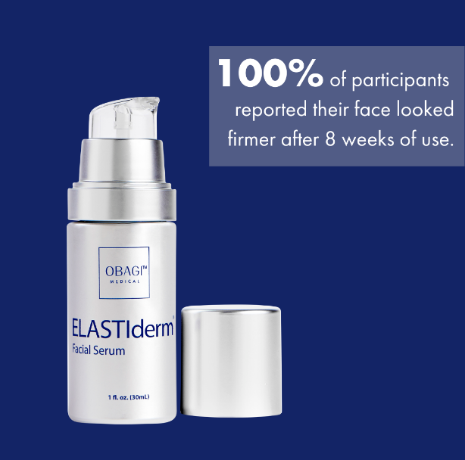
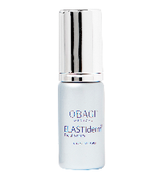
Bounce Back with ELASTIderm Facial Serum

Ideal for use on the face, neck AND chest!
Real results found after 8 weeks use*:
- 100% of participants said their skin looks firmer
- 97% of participants noticed:
- their skin feels more elastic and resilient
- a diminished appearance of crepey facial skin

Enjoy an additional Deluxe Mini 5ml FREE when you buy the Ultimate Obagi Summer Package

Contact us today [insert clinic details]

Find out more at obagiuk.com @obagiuk

