Subject line: Collect Your Free Sample

Try the Ultimate, TINTED Sun Protection
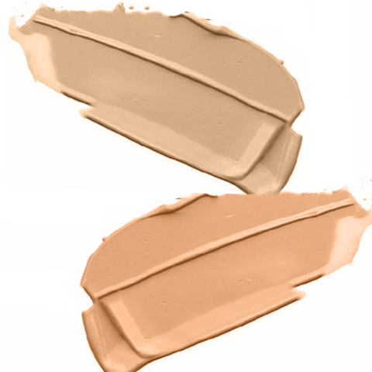

Learn to love your SPF!
The most essential step in your skincare routine, applying sunscreen every day protects your skin from damaging rays and the signs of skin ageing. Finding the best SPF for your skin type just got easier with the [insert clinic name here]

Pop into clinic
Pick up a sample of one of our favourite sun protectors:
Obagi Sun Shield TINT Broad Spectrum SPF50
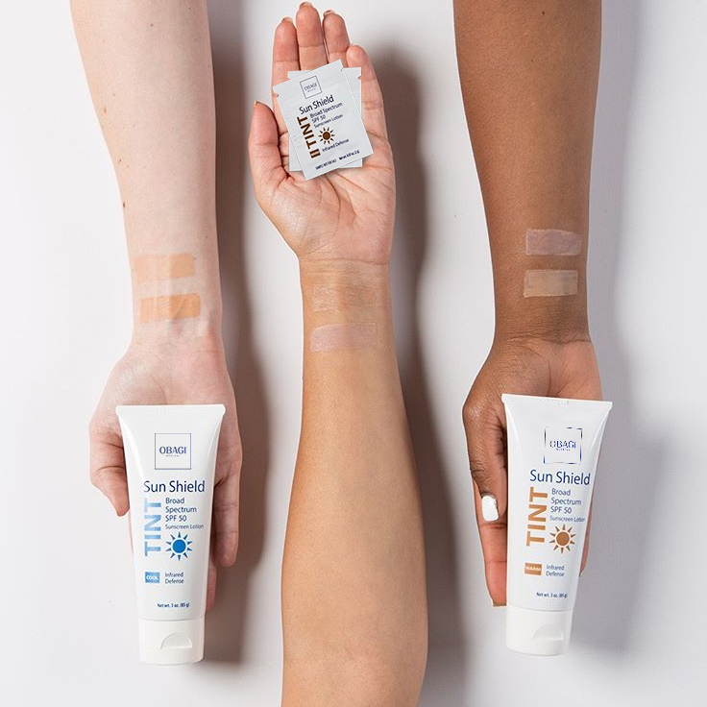
Available in a Warm or Cool tone, these sunscreens match the undertones of your skin, providing light coverage and triple protection, defending against both UVA and UVB rays PLUS infrared!

Find your shade at obagiuk.com @obagiuk

